APM Terminals Pipavav
GUJARAT PIPAVAV PORT LIMITED

Request for Quotation
for
DISMANTLING OF MAIN CONVEYOR SYSTEM
AT APM TERMINALS PIPAVAV

- Scope of Work
GPPL intend to dismantle the existing main conveyor system which is located inside custom bounded zone.

Details of Main Conveyor system are as below:
For coal
Bulk Density :0.8-1.3 T/Cu.m
Lump size : Up to 150mm
Angle of Repose :35 Degree. 40 degrees in Pile
Moisture Content : Up to 15 percent
For Rock Phosphate
Bulk Density :1.28 T /Cu.m
Lump size : Fines
Angle of Repose :28 Degree in Pile
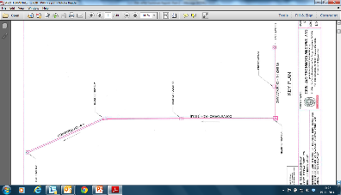
The Main Conveyor system is steel structure, consisting mainly of:
The conveyor system is in 3 segments, R1 is 240m, R2-4 is 660m with 250m travelling tripper and R5 is 300m with 250m tripper travelling.

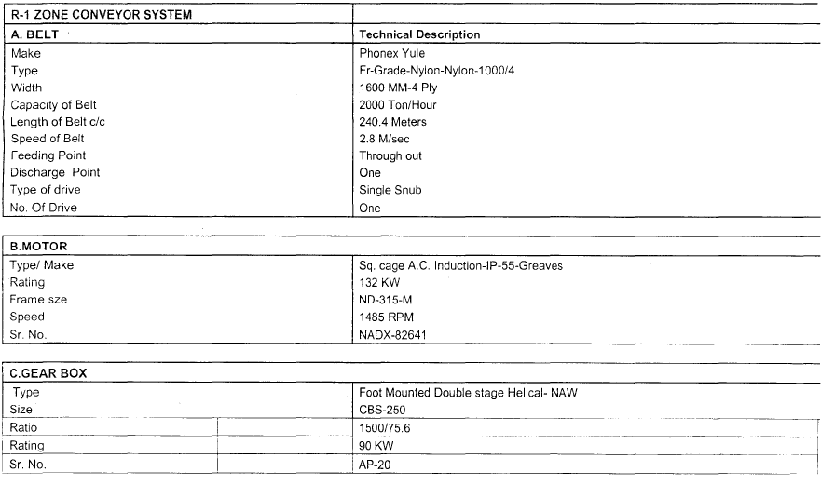
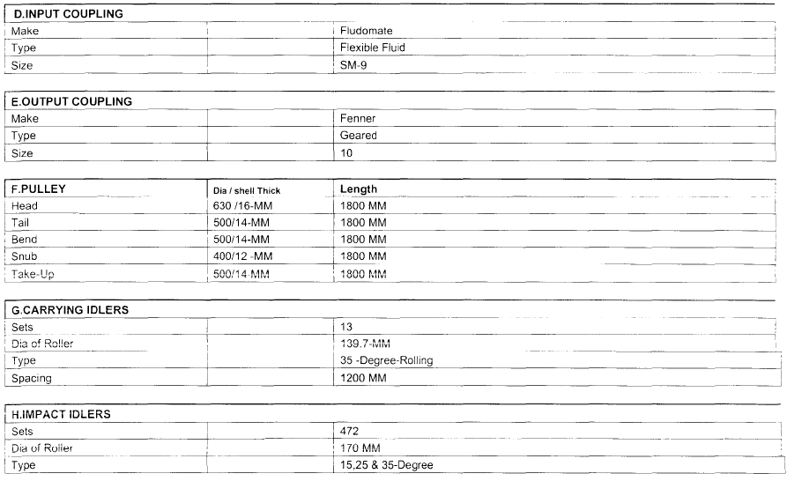
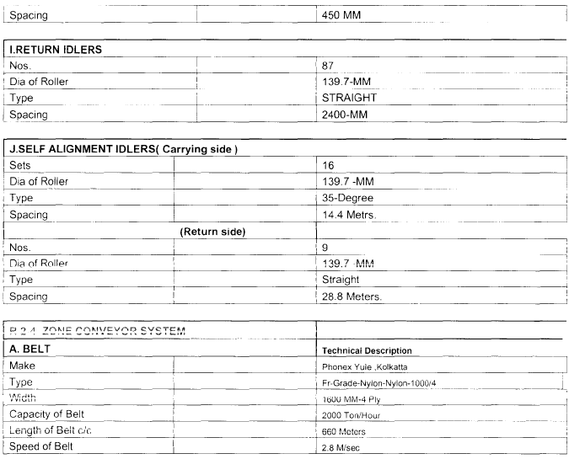
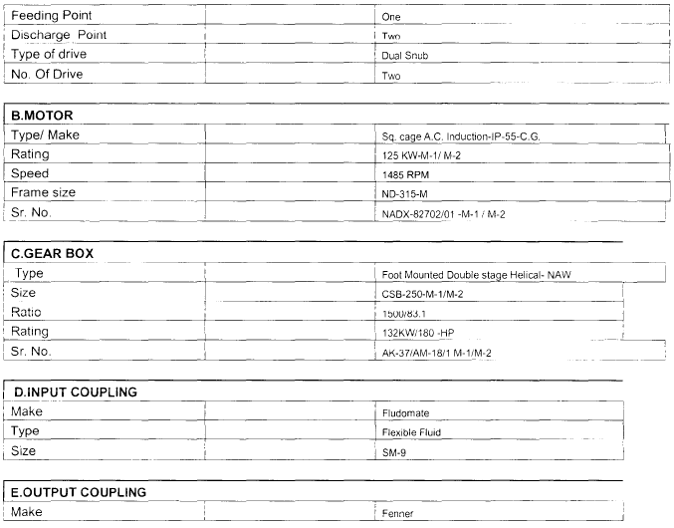
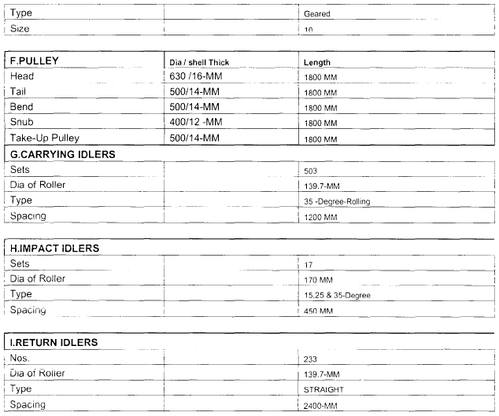
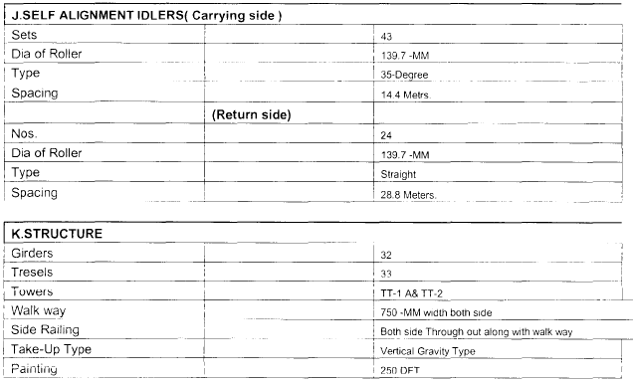
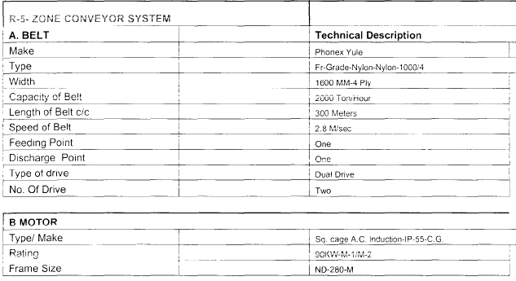
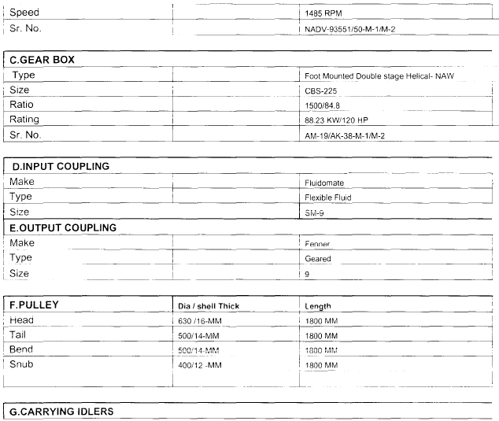
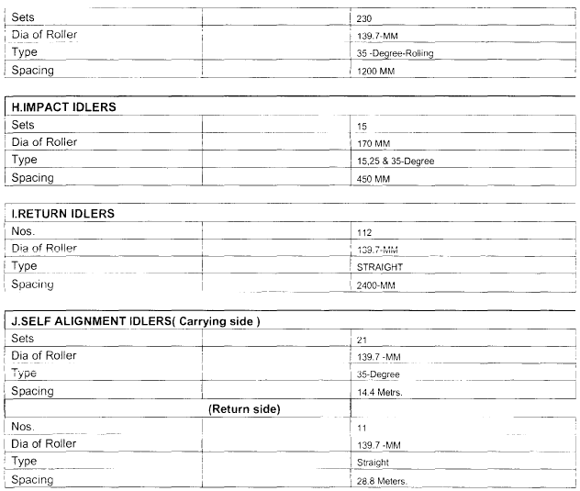
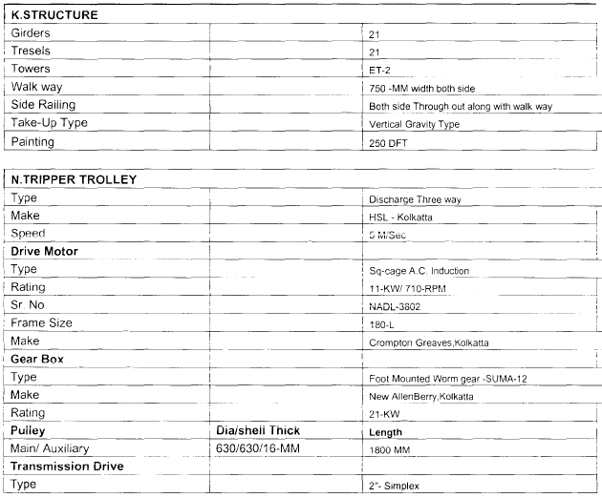
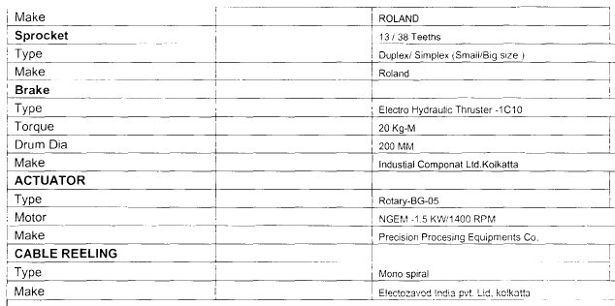

The bidder is required to carry out dismantling work of all above structure and remove the demolished material and debris from the site and disposed as required below.

- Remove the Conveyor Belt installed in R2-4 and R5 Conveyor.
- Dismantling the conveyor steel structure section wise from R1 to R5.
- The civil columns for the conveyor structure need to be removed and levelling has to done.
- Remove the tripper of R2-4 and R5 from the main conveyor system.

The contractor will be solely responsible for obtaining any permission/approval from Local/State/Central Government Authority for disposal/removal of materials and debris and ensuring compliance of the same. The quoted price is inclusive of above compliance process and procedures.

The bidder shall also provide necessary price adjustment for the retrieved steel structures in the quoted price.

The contractor shall properly level, compacted the demolished area upon completion and handover to GPPL for further activities.

- Safety Scope

The bidder shall submit the below documents
- Detailed Lifting plan of all the critical lifts vetted by competent/chartered engineer.
- Maximum ground pressure calculation (during the whole operation) vetted by competent/chartered engineer.
- Certificates of all the lifting equipment, gears and operators as per applicable statutes.
- Mobile crane major Structural modification history of last five years. (If there is any)
- Insurance of the Mobile crane and all the working personnel.
- Risk assessment and traffic plan covering all the tasks/activities of complete operations
- One-year record of machine Logbook or inspection report
- Mobile crane fitness certificate before departure by approved third party.
- Valid Operator license.
- Registration certificate of the Mobile crane.
- Pollution under control certificate.
- Insurance for the erection/ dismantling, Mobile crane and all the working persons.
- Mobile crane major Structural modification history of last five years.
- Submission of approved risk assessment by HSSE.
- All equipment’s should have proper light, horn, safety belt and reverse horn.
- All working staff should wear PPE as per standard.
- Contractor should arrange personal vehicle for their working staff (Pedestrians are not allowed inside the terminal).

- Bidder scope

- Contractor should submit project schedule with activity wise.
- All equipment’s and trailers for shifting of scrap is in his scope.
- Contractor should submit the equipment details and capacity.
- Cleaning of the site after removal of everything
- If any damages happen while dismantling, contractor must bear the repairing charges.
- Removal of cables and machineries as it is possible as per the industry norms.
- Dismantling of the conveyor till parts in big pieces on the ground and further
- Cutting suitable for truck loading to safe mobilize to assigned area in Pipavav yard.
- Providing required enough oxygen and propene for the removal of conveyor system.
- All the necessary consumables not mentioned above, Tools, food, accommodation, and safety.
- Providing the required equipment’s for the Decommissioning of conveyor system are as follows: -
- Crawler Crane – 150 Tons 1 no.
- Crawler Crane – 60 tons, 1 no.
- Certified Man basket for 4 persons, 1 No’s
- Tele handler with telescopic boom or Hydra lift 1 No.’s
- Loading of material into truck for safe mobilization to provide to Pipavav yard
- All the required work man compensation and third-party insurance
- Site skip boxes or drums for housekeeping for the site in different areas
- Empty drum or barrel in good condition to drain oil and fuel for safe work.

GENERAL CONDITION OF CONTRACT
- All Inclusive Rates : All materials, consumable materials, plant & equipment, formworks & tubular metal scaffolding, tools & tackles, Personnel Protective Equipments (PPE), other safety equipment, PPF and insurance for deployment of manpower being engaged by the Contractor for the works and other such items required for satisfactory and timely completion of the works shall be provided by the Contractor. GPPL shall not be responsible for supplying any of these items in whatever form. Rates quoted by the Contractor shall be deemed to include all costs required for arranging all the items specified hereinabove.
The rates quoted by the Contractor and accepted by GPPL shall be inclusive all taxes (Except GST), labour cess & BOCW taxes, TCS, duties & Levies, Royalties, Transportation, Inspection / Testing etc. and other taxes or any other state or corporation tax or any taxes applicable under any rules/regulations/acts/statutes of the State and Central Government duty or any other imposition of such like nature payable by the Contractor under the Contract or any other costs shall be included in the quoted rates and prices.
GPPL shall deduct at source Income Tax and Work Contract Tax as per the prevailing rules of Government from each bill of the Contractor.
- Commencement/Mobilization of Work: Required time for commencement / mobilization of work shall be included in the Work Completion Period
- Deployment of Manpower: Authorized representative of the Contractor shall supervise the work, during the progress of the work and will be fully responsible for proper execution and safety of the workers and the work.
The Contractor should deploy full time, minimum one, qualified & experienced Safety Engineer/Officer/Supervisor at work site for execution of work & day to day activities.
The Contractor will have to depute qualified & experienced minimum one Engineer, Supervisor, Safety Officer with proper power of attorney / Authority letter against individual work order issued by GPPL.
- Work Completion Period: Time of completion is very essence of each work. Contractor shall agree to take all the efforts necessary for timely completion of work and shall deploy sufficient resources (experienced manpower and machinery) to carry out and complete the work. Being an operational Port, all activities like staging, repairing, concerting, rendering etc related to this work will be carried out in accordance with the Port operational time. GPPL shall provide necessary information of the vessel traffic movement in port area time to time.
The time of completion/Validity of this order is 30 days from the date of handing over of work site.
- Payment Terms
  - The contract amount of this work shall Including all taxes (except GST), labour cess & BOCW taxes, TCS, duties & Levies, Royalties, fixing, placing, Inspection/Testing etc. and other taxes or any other state or corporation tax or any taxes applicable under any rules/regulations/acts/statutes of the State and Central Government duty or any other imposition of such like nature payable by the Contractor under the Contract or any other costs shall be included in the quoted rates and prices.
  - GST shall be paid extra as actuals.
  - The applicable taxes, which are prevailing on the date of issuing of work order or imposed latter on by Government statutory body, will be deducted from your running bills. The above rates are inclusive of all labour liabilities and as per minimum wages act and PF, Leave Rules and Bonus Act and all other legal compliance and also it would be revised/ corrected from time to time whenever there is a change made by the govt. in the above rules and liabilities.
  - Gujarat Pipavav Port shall deduct Gujarat State Turnover Tax on Works Contract, Income Tax and any other taxes as per norms of Government of Gujarat & Government of India.
  - Contractor shall submit the invoice and Original Minerals Royalty paid pass / No Due Certificate (NDC) obtaining from local area Geology and Mining authorities (GOG or GOI) along with the final invoice. If Contractor shall not submit any royalties paid proof or no due certificate to the GPPL, GPPL shall deduct the equivalent amount of royalties from the Contractor invoices.
  - The Contractor shall submit the proper Tax invoice as prescribed in the GST Laws and issued in the name of “Gujarat Pipavav Port Limited” with details measurement sheet & drawing with all necessary supporting proof of document in the office of GPPL.
  - Charged GST by the Contractor, shall properly deposited in government treasury account, due tax returns are filed on time and other compliances as required by GST is undertaken well before the due date.
Goods & Service Tax Related Compliances to be adhered to by the Vendor.
  - The Company/Firm undertakes to submit all the necessary information and documents including in particular, GSTIN of the Company/Firm, Company/Firm site, billing location, certificate of GST Registration and such other documents that may be required by Gujarat Pipavav Port Limited (‘GPPL’) to adhere to statutory compliances as applicable under the Goods and Service Tax (‘GST’) law. GPPL shall not be responsible for verification of GST registration number. Any tax Liability arising consequent to non-compliance of law or due to furnishing of incorrect registration number shall be borne by the Company/Firm. In the event if the Company/Firm fails to furnish GST registration number, it will be treated as “unregistered”
  - The Company/Firm acknowledges and agrees that it would adhere to all the applicable GST compliance and accept / modify / reject the output supply as mentioned in GSTR – 1 filed by the Company within the statutory timelines as may be prescribed from time to time by the Government. The Company/Firm undertakes to intimate in case of any modifications required to be made in outward supply mentioned by GPPL in GSTR -1 against the Company/Firm, to GPPL within the statutory timelines prescribed by the Government.
  - The Company/Firm acknowledges and agrees that in the event any enquiry, scrutiny, audit assessment or any other tax proceedings are initiated against GPPL, the Company/Firm shall fully co-operate with GPPL by furnishing the relevant information related to the service provided by GPPL on timely basis as may be required by GPPL from the Company/Firm.
  - In case the GST credit is denied or demand is recovered from GPPL on account of any non-compliance by the Company/Firm, including non-payment of GST Charged and recovered, the Company/Firm shall indemnify GPPL in respect of any claims of Tax, Penalty, Interest, Loss, Damage Cost, expense and liability that may arise due to such non-compliance.
Gujarat Pipavav Port Limited GST Details as under.
GSTN No. 24AAACG6975B1ZS
PAN Card No. AAACG6975B

  - GPPL shall release the payment within 30 (thirty) days from the date of receipt of final invoice in the office of GPPL’s Engineer– in-Charge.

- Sub – Letting of Work/ Sub-contracting : The Contractor shall not sub-let the any portion of work or whole work of the Contract without prior written approval of the Employer. Such approval, if given, shall not in any way whatsoever relieve the Contractor from any of his liabilities or obligations under the Contract and the Contractor shall remain responsible for all the acts, defaults and neglects of any of his sub-Contractor(s) as if they were the acts, defaults or neglects of the Contractor. Employment of piece rate workers shall not be deemed as sub-contracting. On such occasions, the Contractor shall obtain the ‘NO-DUES” from subcontractor and submit along with the final invoice.
- Suspension of Work : Without prior written approval from Engineer to do otherwise, throughout any suspension, the Contractor will maintain its Contractor’s Personnel ready to recommence work. The Contractor will notify the Engineer of details of any of its Contractor’s Personnel that it proposes to redeploy to other projects and the Engineer may require the Contractor not to so redeploy any of the Contractor’s Personnel it considers to be essential to the Works.
The Contractor shall, on receipt of the order in writing of the Client suspend the progress of the work or any part thereof for such time and in such manner as the Client may consider necessary for any of the following reasons: -
- On account of continued non-compliance of the instructions of the Engineer or any other default on the part of the Contractor, or
- For proper execution of the works or part thereof for reasons other than the default of the Contractor, or
- For safety of the works or part thereof.

The Contractor shall, during such suspension, properly protect and secure the works to the extent necessary and carry out the instructions given in that behalf by the Engineer. If the suspension is ordered for reasons as above, the Contractor shall be entitled to an extension of time equal to the period of every such suspension plus a reasonable time as decided by the Client. If the suspension is ordered for reasons other than above, the client shall have powers to suspend the payment under the contract. Such suspension of payment may be continued until default shall have been rectified.
- Escalation & Variation
Variation : The quantities mentioned in the Bill of Quantities are tentative and each individual quantity may vary, or the items may be altogether deleted at the discretion of the architect/consultant/client provided the overall billing for the section does not vary more than 10% on either side.
Employer shall reserve the right to add/alter/delete/modify any of the items or quantities of items as stipulated in the Bill of Quantities. In the event of additional/modified items, the rates to be paid for shall be derived from the rates available for similar items in the accepted Bill of Quantities or decided based on rate analysis and as mutually agreed. In the event of dispute of any kind on the rates, Employer will fix reasonable rates based on rate analysis.
Escalation : No (No) Escalation shall be payable on the Works under this contract due to any reason whatsoever.
- Statutory Approvals (if required) : The approval forms any authority required as per statutory rules and regulations of local/central/ state government shall be the Contractor’s responsibility unless otherwise specified in the tender document. The application on behalf of the Client for submission to relevant authorities shall copies of required certificates complete in all respects shall be prepared and submitted by the Contractor well ahead of time so that the actual construction/commissioning of the work is not delayed for want of the approval/ inspection by concerned shall be arranged by the Contractor and necessary co-ordination and liaison work in this respect shall be responsibility of the contract. Any defective work resulting from poor working ship and / or material supplied by Contractor, as pointed out by any statutory authority shall be rectified by the Contractor his risk and costs. However, any change / addition required to be made to meet the requirement of the statutory authorities; the same shall carry out by the Contractor and shall be paid on unit rate basis. The inspection and acceptance of the work by statutory authorities / Employer shall, however, not absolve the Contractor from any of this responsibility under this contract.
It shall be the sole liability of the Contractor (including the contracting firm/company) to obtain and to abide by all necessary licenses/permissions from the concerned authorities as provided under the various labour legislations including the labour license obtained as per the provisions of the Contract Labour (Regulation & Abolition) Act, 1970.
- Compliance of Statutes, Laws, Rules, Regulations, etc. : The Contractor shall comply with all statutory requirements under the Labour laws, the Provision of Factory Act, Wages Act, Workers Compensation Act, Provident Fund and other applicable statutes, rules, regulations, laws, bye laws of the Government of Gujarat and Government of India.
The Contractor shall indemnify and keep Employer indemnified against all consequences arising from breach of any of the said statutes, rules, regulations, laws, bye laws by the Contractor. The Contractor has to comply and submit all documents such as Labour License, Workman Compensation Insurance policy, Proof of Provident Fund of manpower, wages register etc before start the work
- Anti-Corruption Policy
  - Without prejudice to the generality of the foregoing provisions, each Party or the parties to a work order undertakes and warrants to the other party that neither it nor any member of its Affiliates, nor any agent, consultant or other intermediary acting on behalf of it or its Affiliates, shall, directly or indirectly, in relation to this Agreement or any Work Order created pursuant to it, give, promise or attempt to give, or approve or authorize the giving of, anything of value.
- any employee, officer or director of or any person representing the other party or the other party to a work order or its Affiliates;
- any other person, including without limitation any Public Official;
- a political party or a labour union controlled by any Government or political party ; or
- A charitable or other organization, or an officer, director or employee thereof, or any person acting directly or indirectly on behalf of the same.

for the purpose of (1) securing any improper advantage for Contractor and its Affiliates or GPPL; (2) inducing or influencing that Public Official improperly to take any action or refrain from taking any action in order for either Party or a party to a Work Order to obtain or retain business, or to secure the direction of business to either, or (3) inducing or influencing that Public Official to use his/her influence with any Government or public international organization, or any or any department, agency or other instrumentality thereof, for any such purpose

  - Each Party or a party to a Work Order further warrants and undertakes to the other party that;

    - To the best of its knowledge, neither it nor any of its Affiliates, officers, directors, shareholders, employees, or agents or other intermediaries, or any other person acting directly or indirectly on its behalf, has carried out any of the actions described in Clause 11.1, above; and

    - The persons described in (a), above, shall comply with the provisions of this clause 11.
  - Notwithstanding the foregoing provisions, as regards small value payments to a low level Public Official for the facilitation or expedition of routine tasks which that person must perform as part of his/her job, Contractor warrants and undertakes that it and its Affiliates, officers, directors, shareholders, employees, agents or other intermediaries or any other person acting directly or indirectly on its behalf, shall fully comply with the anti-corruption policy involving such payments, including without limitation cooperating with GPPL to eliminate such payments.
  - Contractor warrants and undertakes that all remuneration received from GPPL under this Work order / Agreement or under a Purchase Order created pursuant to this Agreement is solely intended to compensate Contractor for the Work expressly provided under this Agreement, including without limitation Contractor’s related documented costs and expenses. Contractor warrants and undertakes that it is not receiving remuneration for any other purpose.
  - Contractor warrants and undertakes it shall maintain adequate records in order to be able to verify its compliance with the provisions of this Clause 11, and the other Party or the parties to a Work Order, a certified public accountant designated by the other Party/party shall be permitted to conduct an audit of such records, at the other Party’s/party’s reasonable discretion, in case of any bona-fide dispute between the Parties/parties regarding such compliance, or in case of any investigation by or allegation from any applicable public authority regarding potential violations of any relevant laws involving these matters. The Parties/parties shall cooperate in any such audit and otherwise in providing documentation relating to any such dispute or investigation.
  - Contractor warrants that all responses and related information it has given to GPPL’s regulatory-compliance questions prior to execution of this Agreement are, and undertakes that answers to all such subsequent questions shall be, accurate and complete.
  - Each party shall save, indemnify, defend and hold harmless the other party and its Affiliates from all fines, penalties and all associated expenses arising out of or resulting from its violation of any of its obligations in this Clause 11.
  - Each party may terminate the Agreement and each party to a Work order may terminate the Work Order(s) and to recover from the other party as a debt the amount of any loss or damage resulting from such a termination if any member of it or its Affiliates commits an act which it has undertaken not to commit as included in this Clause 11, whether or not such act was committed before, on or after the date of this Work Order/Agreement.
  - Anti-Corruption, Competition and Sanctions Laws and Regulations
    - Each Party represents that in the context of this Agreement:
- neither itself nor, to the best of its knowledge, any of its affiliates, directors or officers has engaged in any activity or conduct which would violate any applicable anti-bribery, anti-corruption, competition or anti-money laundering laws or regulations and it has instituted and maintain policies and procedures designated to prevent violation of such laws, regulations and rules; and
- neither itself nor, to the best of its knowledge, any of its affiliates, directors or officers is: (i) the subject of any sanctions (a “Sanctioned Person”) or (ii) located, organized or resident in a country or territory that is, or whose government is, the subject of sanctions broadly prohibiting dealings with such government, country, or territory (a “Sanctioned Country”)
    - Each Party undertakes that it shall not:
- engage in any activity or conduct which would violate any applicable anti- bribery, anti-corruption, competition or anti-money laundering laws or regulations; and
- directly or indirectly, lend, contribute or otherwise make available any amount received under this Agreement to a Sanctioned Person or a person located in a Sanctioned Country or otherwise violate any applicable foreign trade control regulation or sanction.
- Compliance
  - Short-form Compliance Each Party
    - shall comply with:
- any applicable anti-bribery, anti-corruption, or anti-money laundering laws or regulations;
- any anti-competition laws;
- any applicable export control laws;
- any applicable person-related and country-related embargo or sanction laws or regulations; and
- any other applicable law, rule, decree or regulation; an

    - confirms it has established processes and maintains policies and procedures designated to prevent violation of any of the laws or regulations in Clause 12(a)(i) through (v).
  - Long-form Anti-Corruption, Competition and Sanctions Laws and Regulations
    - Each Party represents that in the context of this Agreement:
- neither itself nor, to the best of its knowledge, any of its affiliates, directors or officers has engaged in any activity or conduct which would violate any applicable anti-bribery, anti-corruption, competition or anti-money laundering laws or regulations and it has instituted and maintain policies and procedures designated to prevent violation of such laws, regulations and rules; and
- neither itself nor, to the best of its knowledge, any of its affiliates, directors or officers is: (i) the subject of any sanctions (a “Sanctioned Person”) or (ii) located, organized or resident in a country or territory that is, or whose government is, the subject of sanctions broadly prohibiting dealings with such government, country, or territory (a “Sanctioned Country”).
    - Each Party undertakes that it shall not:
- engage in any activity or conduct which would violate any applicable anti-bribery, anti-corruption, competition or anti-money laundering laws or regulations; and
- directly or indirectly, lend, contribute or otherwise make available any amount received under this Agreement to a Sanctioned Person or a person located in a Sanctioned Country or otherwise violate any applicable foreign trade control regulation or sanction.
  - Audit and Inspection Rights : During the term of this Agreement, at the reasonable request of a Party with at least [three (3)] business days’ prior notice, either Party may at its own expense during regular business hours [inspect] [have a mutually-agreed independent third party inspect] [the facility and] audit the other Party's books, records, and other documents as necessary to verify compliance with the terms and conditions of this Agreement.
  - Remedies
    - If a Party breaches any of its obligations or representations in this Clause [X] (Compliance):
- such Party shall indemnify and hold the other Party harmless from all fines, penalties and all associated expenses arising out of or resulting from such violation. Notwithstanding the foregoing, no Party shall be liable for any indirect or consequential loss or damage or any loss or damage due to loss of goodwill or reputation; and
- the other Party may terminate this Agreement and recover from the violating Party as a debt the amount of any loss or damage resulting from the termination.
- Health, Safety & Environment Policy
The Contractor shall strictly comply with “Contractor’s Safety Guidelines” and “Consequence Management” (copy enclosed) and all other local regulations which may be in force from time to time.

  - Contractor shall strictly follow up Port security rules. Contractor shall arrange and responsible for all securities of their work site, workers, staffs, materials etc in port area. Contractor shall responsible for taking necessary permission for the execution of work from respective state/central government authority as required. Contractor shall arrange necessary gate pass for entry & exist of his martial, manpower, equipments etc while working inside the pipavav port custom bonded area as per Custom Department-Pipavav port direction. Contractor shall fully responsible to comply of all custom rules & regulation inside the custom bonded area.

  - All workers and staffs of Contractor and Contractor’s sub-Contractors shall wear safety boots, safety helmets, visibility jackets, safety harnesses at work site and when working at heights during working hours. If any person of the Contractor fails to maintain PPE requirements, GPPL will fine Rs. 5000/- per occurrence at sole discretion of GPPL. Minimum PPE requirements for all Contractor personnel at site are Helmet, F. L. Jacket and Safety shoes with steel toe.

  - The working hour of individual persons/workers/staffs of Contractor and Contractor’s sub – Contractors shall not permit more than 8 hours per day at work site. If Contractors shall fails to follow up GPPL will fine Rs 10000/- per incident. If Contractor shall working in 24 hours or in night hour in shifts, the Contractors shall arrange adequate lighting arrangement and precautions, safety equipments, tools & tackles etc his own cost.

  - Contractors shall strictly follow up vehicle running speed in the port area as under.
    - Outside Custom bonded area – 40 km per hour
    - Inside Custom bonded area – 30 km per hour
    - Jetty and container yard area – 20 km per hour

  - If Contractors shall fails to follow up above speed limit in port area GPPL will fine Rs 5000/- per incident. All the vehicles and equipments used for this work the Contractors shall comply all applicable rules & regulations.

  - Chewing and spitting of tobacco, gutka, mava, liquor or any such substances are strictly prohibited in Port area. If any person of the Contractor found chewing tobacco, he will be sacked from the site and Rs. 5000/- will be fined to the Contractor.

  - Staff /workers of Contractors and his sub-Contractors shall violations of port safety and security rules, GPPL will fine Rs. 30,000/- for non-compliance report, Rs. 20,000/- near miss report, Rs 10,000/- Observation report per occurrences and Rs. 5,000/- Without PPE per persons.

  - Contractors shall submit risk assessment of this work & taken approval from HSSE Department GPPL before execution of work.

  - Contractors shall arrange and fix metal barricading surrounding worksite for safety in his risk and cost.

  - Contractor shall arrange diversion as per site condition including all required necessary arrangement like manpower, equipments, material etc.

  - Contractor shall arrange and fix proper metal scaffolding for staging for the work as per APMT Guidelines and conform the latest IS standard.
- Responsible Procurement : The Supplier shall comply with all applicable laws, rules, & regulations, Orders. conventions, or ordinances of the country(ies) where Services/Work is performed or where Goods are produced and/or relate to the provision, licensing, approval or certification of the Services/Goods, including, but not limited to, those relating to occupational health and safety, environmental matters, wages, working hours and conditions of employment, subContractor selection discrimination, data protection and privacy. Further the Supplier shall respect and commit to implementing APMM's Supplier Code of Conduct ("the Code") as amended from time to time and found at;

http://www.maersk.com/sustainability/pages/thirdpartycodeofconduct.aspx

or alternatively an internationally recognized standard within the areas of human rights, anticorruption, environment and labour, such as but not limited to United Nations Global Compact (UNGC) and Supplier agrees to accommodate any potential audit pursuant to verification of the same by APMM or Buyer. The Supplier shell require their own suppliers to implement similar rules and as appropriate pass on such requirements to their sub suppliers and so on. The original English version of the Code (as of August 2013) shall prevail in case of any disputes or discussions concerning the content and obligations of either Party. The Supplier warrants that it will register itself in APMM's CSR system (www.MaerskResponsibleProcurement.com) within 14 days after the date of the last signature on the Agreement and shall - if subsequently requested by APMM - provide documentation necessary for APMM to evaluate Supplier's ability to meet the requirements listed in the Code. Should the Supplier be unable to meet the listed requirements, the Supplier will agree to develop and execute an improvement plan.

Buyer shall at any time and without notice have the right to appoint at its own cost, charge and expense a well reputed third-party auditor (hereinafter referred to as "Buyer's Auditor") to audit and verify all matters in connection with Supplier's compliance with the previous Clause. Supplier shall cooperate with the Buyer's Auditor and provide access to all relevant sites, people, and interviews with workers and documents. If the Buyer's Auditor uncover(s) any material concern, Supplier shall without any undue delay present Buyer with an improvement plan which shall ensure that all concerns are dealt with and remediated in a manner satisfactory to Buyer.

Supplier's repeated violation of the Code/UNGC/International Bill of Human Rights and/or its failure to collaborate with Buyer's Auditor during an audit and/or its failure to· collaborate with Buyer in implementing or developing improvement plans shall be considered a material breach of this Agreement If Supplier commits any such breach of or fails to observe or perform any material obligation contained in the Code/UNGC/International Bill of Human Rights, and/or any agreed improvement plan, and such breach or failure has not been remedied to the satisfaction of Buyer within twenty-eight (28) days of receipt by the Supplier of a notice from Buyer requiring Supplier to remedy the same (or such longer period as may be specified in the said notice), Buyer shall be entitled to terminate the Contract in accordance with Clause of this agreement-work order.

- Confidentiality : The Contractor shall undertake to maintain strict confidentiality and refrain from disclosure thereof, of all Contract documents, Drawings and the Employer’s operations and affairs as private and confidential information & data shall not publish or disclose the same or any particulars thereof in any trade or technical paper or elsewhere without the previous consent in writing of the Employer. Contractor shall be responsible to ensure maintenance of such confidentiality in respect of their behalf and on behalf of their employees, representatives and associates involved in related activities. If any dispute arises as to the necessity of any publication or disclosure for the purpose of the Contract the same shall be referred to the decision of the Employer whose award shall be final.
- Responsibility of Contractor : All expenses towards Mobilization at site and demobilization including bringing in equipment, work force, materials, dismantling the equipment, clearing the site etc. shall be deemed to be including in the prices quoted and no separate payment on account of such expenses shall be entertained.
Contractor shall be solely responsible for making available for executing the work, all requisite construction equipment, special aids, cranes, tools trackless and testing be equipment and appliances, such construction equipment etc. shall be subject to examination by GPPL and approval for the some being in first class operating condition. Any discrepancies repaired or the equipment replaced altogether, by the Contractor. GPPL shall not in any way be responsible for providing any such equipment, machinery, tools and tackles etc.
Preparing approaches and working area for the movement and operation of the equipment, levelling the areas for assembly and erection shall also be the responsibility of the Contractor, the Contractor shall acquaint himself with access availability and facilities such as railway siding, local labour etc. to provide suitable allowances in his quotation. The Contractor may have to build temporary access road to aid his own work which shall also be taken care while quoting for work.
Contractor shall not use any, materials issued by PPL for installation purposes for laying temporary lines, erection aids etc. misuse of materials will be seriously viewed and deductions at penal rates will be made from the Contractor’s bills for such quantities that are missed. Contractor shall arrange and steel scaffolding materials wherever scaffolding is required for execution of works.
- Rights of Way and Facilities : The Contractor shall negotiate with the Employer for the use of an area of land sufficient for the Contractor's work area, in near proximity to the Site of the Works. This work area shall be sufficient to accommodate the Contractor's site offices and all material storage, fabrication and testing facilities which the Contractor desires or which are required under the Contract. However, labour shall not (not) be allowed to camp within the boundary of Employer.
- Security of the Site : The Contractor shall ensure the security of the Site during the whole period of execution and shall be responsible for taking the necessary steps to prevent any loss or accident, which may result from carrying out the Works. The Contractor shall take all essential steps, on his own responsibility and at his expense, to ensure that existing structures and installations alongside the road are protected, preserved and maintained
- Contractor’s Operations on Site : During the execution of the Works, the Contractor shall keep the Site free from all unnecessary obstruction, and shall store or dispose of any Contractor’s Equipment or surplus materials. The Contractor shall clear away and remove from the Site any wreckage, rubbish and Temporary Works which are no longer required. The Contractor shall be responsible for site maintenance, cleaning and waste management in accordance with the detailed requirements of the Specification.
Prior to the submittal of the Contractor’s application for a Taking-over Certificate for a Section, the Contractor shall undertake final cleaning of all completed permanent Works to remove all surplus material, construction debris, wreckage and rubbish. Drainage elements shall be flushed clean to remove any accumulated material and all other service pits shall be cleaned out with particular attention to any pit drainage or weep holes. The frames of all cast iron service pit access covers shall be cleaned and greased. The final cleaning of the site shall be to the satisfaction of the Engineer.
- Adequate precautions during progress of works : The Contractor shall give all notices required by any statutory provision or by the regulation and/or bye-laws of any local authority and/or of any public service, company or authority affected by the works or with whose system the same are/will be connected and he shall pay and indemnify the Employer and Consultant against any fees or charges demanded by law under such act/regulations/bye-laws in respect of the works and shall make and supply all drawings and plans required in connection with any such notices.
During the execution of the work, the Contractor shall at his own cost provide adequate materials for all works relating to shoring, timbering, shuttering, scaffolding etc., and execute the same in such a way as to ensure in abundant measure, the stability and safety of all structures, excavations and works and further ensure that no physical harm is caused or likely to be caused to any persons or no damage or loss is caused to any property.
Existing roads, ways, paths or water courses shall not be blocked, cut through, altered, diverted or obstructed in any way by the Contractor, save to the extent permitted by the Owner at the Contractor's cost.
During the progress of any work in or upon any street or thoroughfare, the Contractor shall make adequate provision at his own expenses for regulation of traffic on such street, or thoroughfare, or for securing safe access to all premises approaches from such street, or thoroughfare, or for service of any drainage, water supply or means of lightening which may be interrupted by reason of the execution of such work, and shall erect and maintain at his own cost such barriers, lights or other safeguards and other precautionary measures as may be prescribed by the Owner or the authority concerned for the regulation of traffic, and post all watchmen necessary to prevent any accidents.
The Contractor shall be responsible for taking all precautions to ensure the safety of the public, whether on the property belonging to the Owner or other and shall post at his own expenses such lookout men as may, in the opinion of the Owner be required to comply with the regulations appertaining to the work.
The Contractor shall provide all watchmen necessary for the protection of the site, the works and of the materials and plant and all things on site during the progress of the works and shall solely be responsible for and shall take all reasonable and proper steps for protecting, securing, lighting and watching all places on or about the works and site which may be dangerous to whomsoever.
Contractor shall at all times provide and maintain adequate protection against weather (including but not limited to rain, winds, storms or heat) so as to preserve the work, material, equipment and fixtures free from damage and deterioration.
- Removal of Utilities & Man-Made Obstacles : The Contractor shall at his own cost survey the Site and identify all Utilities. The Contractor shall to the extent necessary for the execution and construction of the Works undertake (or procure the undertaking of) all necessary works to divert any Utilities to the extent necessary for the execution and construction of the Works. All such works of Utilities Diversion are deemed to be an integral part of the Works and shall be paid for as part of the Contract Price.
The Contractor shall at his own cost remove from the Site any man-made obstacles (including any improvements left therein by squatters) and to the extent necessary for the execution and construction of the Works, any form of contaminants or pollutants or other environmental hazards which may be discovered during the execution and construction of the Works.
The Contractor shall at his own cost remove from the Site any man-made obstacles (including any improvements left therein by squatters) and to the extent necessary for the execution and construction of the Works, any form of contaminants or pollutants or other environmental hazards which may be discovered during the execution and construction of the Works.
- Protection of the Environment : The Contractor shall ensure that emissions, surface discharges and effluent from the Contractor's activities shall not exceed the values stated in the Specification or prescribed by applicable Laws.
Contractors shall disposal of all environmental effected waste such as construction waste, plastic waste, site cleaning waste, chemical waste, Petroleum products waste or any type of hazardous waste etc including transportation at outside of Port premises. Contractors shall follow up the disposal method as per Central/state environment rules & regulations and acts. GPPL shall not provide any extra charges for this work.
- Facilities for Other Contractors : The Contractor shall afford all reasonable facilities and cooperation to any other Contractor who may be working at the same site. No additional time for completion or additional cost shall be admissible due to interference from any other Contractor working at the site.
- Water, Power, Weight Bridge & site office
  - Water supply : If required, Contractor shall collect water for the works from water filling point located within Employer central reservoir area. He shall make his own storage arrangements. The Contractor shall pay for the water at rates fixed by Employer.

  - Power supply : If power is available near the Work site, it may be made available to Contractor on payment at rates fixed by Employer. Otherwise, the Contractor shall make his own arrangements for the electricity required for the execution of the Works. However, Contractor shall lay his own cables and provide his own switchgear approve by Employer and electricity meter for drawing the power.

  - Weigh Bridge : If the Contractors shall supply any item as per bill of quantities or adding new item in bill of quantities, Gujarat Pipavav Port shall conduct weight at Weigh Bridge located in side of Port premises. The Contractor shall pay weighment charges at the rates fixed by Gujarat Pipavav Port.

  - Site Office, Camp & Storage Godown : Gujarat Pipavav Port shall not permit the Contractor to setup a site office, labour camp, storage godowns in port premises for execution of this work.

- Damage to Property : During the execution of the Work, Contractor or Contractor’s sub-Contractor or their employees shall ensure that none of the property of Employer is damaged, whether under or above ground. In the event of such a damage-taking place due to the Contractor’s fault, Employer shall be entitled to recover the cost of damage and/or the cost of repairs to make good the damage from any of the dues of the Contractor. The decision of the Engineer in this regard shall be final and binding.
- Damage to person and property : The Contractor shall be responsible for all injury to persons (third party) inclusive of animals or things, and for all damage to the structures and buildings, which may arise from the operations or neglect of himself or his agent or of any sub-Contractor or any of his or a sub-Contractor's employees; whether such injury or damage arises from carelessness, accident, or any other cause whatever in any way connected with the carrying out of the contract. This clause shall be held to include any damage to Wharf, Quay, building including foundation whether immediately adjacent or otherwise, and any damage to road, street, footpath, boundary walls, bridges, sub- ways, all water mains and sewer mains, telephone and electric mains or any other property or properties either of Owner or any other third party as well as all damage caused to the buildings, and the works forming the subject of this contract by any reason whatsoever.
The Contractor shall at his own cost reinstall all damage of every sort so as to deliver the whole of the contract work (including damaged structures and buildings on neighbourhoods and third party’s properties) complete and perfect in every respect and so as to make good or otherwise satisfy all claims for damage to the property of third parties.
- Termination of Contract : If the Contractor does not commence and progress the Works in a professional, expeditious and satisfactory manner and in accordance with Approved Works Programme or does not comply with the Specifications or indulges in unhealthy practices such as illegal activities, bribes, etc., Engineer shall have the right to terminate the contract by giving notice of 7 (seven) days to Contractor. The decision of Engineer in this regard shall be final and binding.
In such an event, the items of work executed conforming to the contract requirements shall be measured as on the effective date of termination and paid for after deducting any amounts which may become due and payable to Employer as a consequence of premature termination of the contract, as well as, the additional cost which Employer may be required to incur in completing the balance works at the Contractor’s risk and cost. Further, in the event of termination of contract, the amount of Performance Guarantee (if any) and Retention Money shall be forfeited and become payable to Employer and the Bank Guarantees (if submitted) for the same shall be encashed by EMPLOYER. However, if the contract is terminated, again by giving 7 (seven) days’ notice, due to Force Majure conditions or administrative reasons or any other reason not attributable to the Contractor, payment for the works executed satisfactorily and conforming to the specifications up to the effective date of termination shall become due to the Contractor. In such an eventuality, the work as accepted shall be treated as completed, retention money clauses operated on pro-rata basis in relation to accepted work & Performance Bank Guarantee released.
- Force Majeure : In the event of Force Majeure conditions, Engineer shall grant reasonable extension of time to the Contractor for completion of the Works without any other type of compensation. In case it is not possible to proceed with the Works due to Force Majeure events, the contract may be terminated by mutual agreement between Employer and the Contractor. Force Majeure event shall mean event or circumstances such as acts of God, cyclone, earthquake, or any such natural calamity, riot, war, rebellion or similar events.
- Disputes and Arbitration : Any dispute or difference arising between the Parties out of or in connection with the Works shall promptly and in good faith be negotiated with a view to its amicable resolution and settlement. In the event no amicable resolution or settlement is reached within a period of thirty (30) days from the date on which the dispute or difference arose, such disputes and/or differences shall be referred to arbitration and settled by a sole arbitrator appointed by both the parties on mutual consent, pursuant to Arbitration & Conciliation Act of 1996 and any amendments thereof and all proceedings in such arbitration shall be held in Mumbai. Notwithstanding the existence of any claim by the Contractor and / or continuance of any arbitration proceedings initiated by the Contractor, the Contractor shall continue to perform the work under the scope of this agreement, unless EMPLOYER has ordered suspension thereof or any part thereto or EMPLOYER has terminated the contract, and the Contractor shall remain liable and bound in all respects the agreement, and further the continuance of the arbitration proceeding shall not in any way diminish the rights of EMPLOYER under termination of the contract, and the Contractor shall remain liable and bound in all respects under this contract.
- Stamp Duty : The Stamp Duty for this Purchase Order / Work Order / Agreement / Contract shall borne by Contractor/Vendor/Supplier. If any dispute arises under this Purchase Order / Work Order / Agreement / Contract, The Contractor/Vendor/Supplier is responsible to complete the compliances under stamp duty liability as per law.

- Law and jurisdiction : Any or all-legal matters relating to the works and the contract shall be subject to Ahmedabad jurisdiction only.

Dismantling of Existing Main conveyor system at APM Terminals Pipavav
Bill of Quantities
Sr. No. | Description | Unit | Qty | Rate (INR) | Amount (INR)
01 | Dismantling of 1.2 km Main conveyor system | LS | 700T
Total Amount (INR)
Taxes
Total Amount (INR)

The bidder shall also provide necessary price adjustment per weigh for the retrieved steel structures in the quoted price. Rate per MT ₹53,000 /-

Note :
- The concrete debris needs to dismantle in small fragments not larger than 100mm and dumped, grade and levelled at designated location inside the port area.

- The reinforcement bar needs to be segregated from the RCC before disposal of the structure. The ownership of segregated/retrieved rebar shall be weight and transferred to the assigned contractor and the same needs to shift out of the port within 15 days from the date of retrieval.

- The contractor will be solely responsible for obtaining any permission/approval from Local/State/Central Government Authority for disposal/removal of materials and debris and ensuring compliance of the same. The quoted price is inclusive of above compliance process and procedures.

- The contractor shall properly level, compacted the demolished area upon completion and handover to GPPL for further activities.

