APM Terminals Pipavav
GUJARAT PIPAVAV PORT LIMITED

Expression of Interest (EOI) & Request for Proposal (RFP) for
Appointment of Architectural Consultant
for
Architectural & Engineering Services for developing colony master plan and setting up detailed architectural design of residential colony units
at APM Terminals, Pipavav.

1. INTRODUCTION 3
1.1 Background 3
1.2 Location 3
2. OBJECTIVE 3
3. Details and status of the Projects 4
4. SCOPE OF WORK 4
5. SERVICE AGREEMENT 9
6. PROPOSAL SUBMISSION 9
6.1 Technical Proposal 9
6.2 Financial Proposal 10
6.2.1 Payment Schedule 11
6.2.2 Payment terms 11
6.3 Timeline 12

INTRODUCTION

Background
APM Terminals (“APMT”) operates a global ports, terminals, and inland services network of 22,000 industry professionals, operating 76 terminals and 160 inland services in 68 countries. The APMT provides port management and terminal operations to over 60 liners, shipping and port customers, and wide range of local inland transportation and cargo services around the world performing a central role in global trade and logistics.
Gujarat Pipavav Port Limited (GPPL) is managed and operated by APM Terminals, the ports and terminals company of the A.P. Moller-Maersk Group. GPPL, a successful public-private enterprise, is emerging as an important gateway port on the West Coast of India for handling Multi Commodities which include Containers, Bulk, Liquid and Ro-Ro cargo.

Location

Pipavav port is located on the western bank of Gulf of Khambhat in Saurashtra region of Gujarat, at a distance of 140 km south-west of Bhavnagar, and approx. 152 n.miles northwest of Mumbai, Maharashtra. It is situated at a latitude of 20°54'N and a longitude of 71°30' E.
Nearest Airports are Bhavnagar (136 km), Diu (85 km), Rajkot (203 km) & Ahmedabad (321 km). Nearest Railway Stations are Rajula (30 km), Bhavnagar (136 km), Rajkot (203 km), Ahmedabad (321 km).

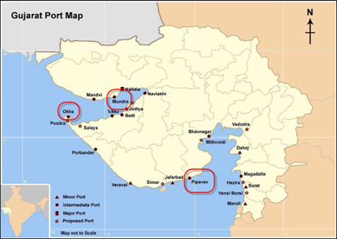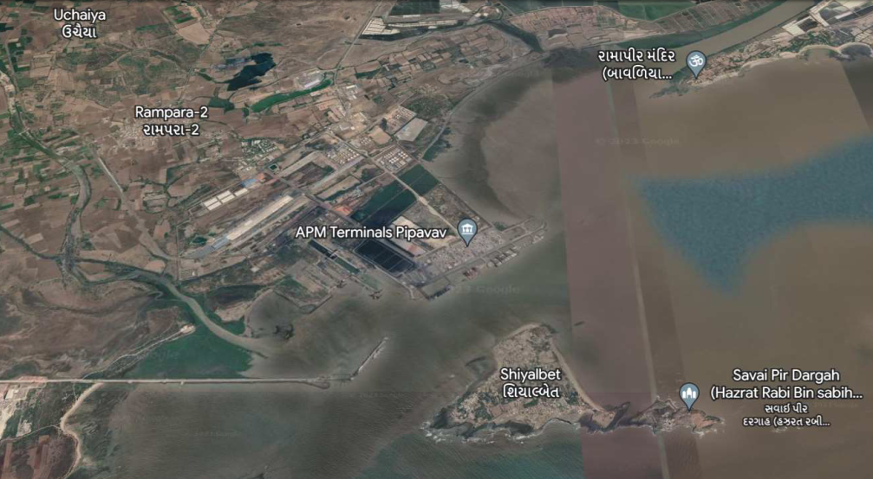
Figure 1.1: Location Map of Pipavav Figure 1.2: Google maps image of the terminal

OBJECTIVE

GPPL is currently having residential colony set up for its employees and various stakeholders at port itself including various amenities for better living standards and comfort. Looking to the consistent need and vitality for accommodating additional people with increase in the business and operational resources, GPPL envisages to develop a master plan in available area and develop residential facilities phase wise. In this perspective, as of now Four buildings consisting of 24 residential units of two and three BHK are being taken up for construction in Phase I.
In this regard, GPPL (the “Employer”) wishes to appoint an architect cum consultant / architectural firm (“Architect”) for Architectural & Engineering Services for developing colony master plan and setting up detailed architectural design of residential colony units at APM Terminals, Pipavav (the “Assignment”).
The objective of the assignment broadly consists of developing a master plan considering existing residential units and optimum utilisation of available space for development of new units keeping in view the future requirements. This also includes development of architectural and engineering design, drawings and tender for Four residential buildings consisting of six units each, i.e., three buildings with six nos. of 2 BHK units each and one building with six nos. of 3 BHK units.
Expression of Interest & Request for Proposal are invited from the eligible Architect cum Consultant / architectural firm having proven experience in completion of similar projects.

Details
The nature of services to be provided by the Architect cum consultant / architectural firm will include, but will not be limited to, preparing Architectural Design and Details, Lay out plan, Structural Design, planning of all services, preparation of BOQ with due emphasis on quality of design. Proposed construction shall be in conformity as per GRIHA (Green Rating for Integrated Habitat Assessment) National Green Building Rating System to achieve minimum 3-star rating as required.
The scope of work includes but is not limited to site evaluation / assessment, preparation of concept plan, Design Basis Report (DBR), preparation of preliminary, detailed architectural and structural designs, preparation of working / GFC drawings, preparation of tender documents, BOQ and detailed technical specifications, planning and design of utility service system, interior designs, landscape architecture, planning and designing of area drainage, integration / development of new facilities for STP, WTP, selection of material / approval of samples, periodic inspection and evaluation of works, check and approve drawings submitted by contractors, approval and submission ‘as built drawings’.
The term "ARCHITECT" shall mean any person, who at the time of his application is registered with the Council of Architecture under the Architects- Act-1972. Where the expression of Interest is made by a team, its leader shall be an "ARCHITECT" and where the application is made by proprietorship firm whose proprietor is a qualified architect registered with the Council of Architecture of India or a partnership firm in which all the partners are qualified architects registered with the Council of Architecture of India. The applicants should be in the architectural consultancy business in the present name and style for a period of minimum 5 years.
The firm must have provided comprehensive architectural consultancy services for setting up minimum five similar projects with certificate of completion.

SCOPE OF WORK AND SCHEDULE
The Architect cum Consultant / Architectural Firm is required to provide all such services which are required for smooth Planning & execution of the project. The broad scope of work for the Architect cum Consultant / Architectural Firm proposed to be appointed for the proposed project is mentioned as under.
Collection of necessary data from GPPL / site investigations and preparation of design brief.
- Master Plan development and Phase I-unit design, including site development includes design of Overall master plan, specific design of Phase I buildings, Sanitary, plumbing, drainage, water supply, landscaping, road, parking, Play Area, Rain Harvesting System, Solar system, Fencing etc.
- Electrical (Internal & External), electronic, systems and design.
- Ventilation and other systems.
- Interior Layout, Interior Design Concept etc.
The Architect shall render the following services:
- CONCEPT DESIGN [STAGE 1] :
Ascertain client’s requirements, examine site constraints & potential; and prepare a design brief, proposed layout with various options for approval of master plan. Prepare report on site evaluation, area utilisation, prepare drawings and documents in alignment with the requirements for development of the master plan.
Prepare conceptual designs with reference to requirements given and prepare rough estimate of cost on area basis for construction.
- PRELIMINARY DESIGN AND DRAWINGS [STAGE 2] :
Prepare preliminary designs incorporating required changes after discussion with the client and prepare the preliminary drawings, sketches, model, etc., for the client’s approval along with preliminary estimate of cost on area basis.
- DRAWINGS FOR APPROVALS [STAGE 3] :
Prepare drawings necessary for approvals and ensure compliance with codes, standards and statutory requirements / legislation, as applicable. Preparation of 3D drawings wherever required as per the Client’s requirement.
- WORKING DRAWINGS AND TENDER DOCUMENTS [STAGE 4] :
Prepare working drawings, technical specifications and schedule of quantities sufficient to prepare estimate of cost and tender documents including code of practice covering aspects like mode of measurement, method of payments, quality control procedures on materials & works and other conditions of contract.
Preparation of sketch designs with two/three alternative schemes including carrying out necessary options for the proposal till the designs are finally approved by the client and making block estimates.
Prepare drawings and documents for the said work. Electrical Design drawing along with HVAC drawings. Prepare the Schedule chart based on the activities and the time period required for the completion of said project including activities up to L3 level in MS Project / Primavera.
- APPOINTMENT OF CONTRACTORS [STAGE 5] :
The scope includes support pre and during the tendering. Answering specific queries from the bidders, analysing the tenders received and provide comparative analysis. Rate analysis of items for the submitted estimate and specifications etc are also included in this scope of work.
- CONSTRUCTION [STAGE 6] : OPTIONAL
Prepare and issue working drawings and details for proper execution of works prior to the construction phase and modify them as and when required to suit the site condition during construction phase.
Preparing working details for the project including structural, water supply, electrical, roads, area development, sewage, drainage, firefighting etc.
Approve samples of various elements and components. Check and approve drawings submitted by the contractor/ vendors.
Visit the site of work, at intervals mutually agreed upon, to inspect and evaluate the progress of Works and wherever necessary to clarify any decision, offer interpretation of the drawings/specifications, attend conferences and meetings to ensure that the project proceeds generally in accordance with the conditions of contract and keep the client informed and render advice on actions, if required.
Issue Certificate of Completion of works. Issue two sets of as built drawings including services and structural drawings
The list of duties mentioned above is only indicative and the Architect cum Consultant / Architectural Firm will have to assume full responsibility for completion of the project both qualitatively and quantitatively as per accepted contract conditions in the best possible workmanlike manner in all respects till its occupation within the agreed time schedule and cost by following laid norms/procedure/guidelines in an open and transparent manner to the satisfaction of the Client and towards achieving this goal whatever is required to be done will have to be arranged by the Architect cum Consultant / Architectural Firm with the approval of the client.
- COMPLETION [STAGE 7] :
Issue two sets of GFC drawings and transfer editable soft copies of such drawings during tendering stage.
Issue As built drawings and transfer editable soft copies of such drawings including services drawings after completion of work (with stage F).

- REPORTING
Submit fortnightly review reports during master planning, detailed design stage and construction supervision (Optional) including but not limited to updates on planning, detailed design, schedule, tendering and estimates.
The scope of services provided above is not exhaustive but indicative and it shall be the sole responsibility of the Consultant to render assistance and services required to fulfil the obligations broadly envisaged herein.

SERVICE AGREEMENT

All the terms and conditions will be as per APMT standard Services Agreement (2014) as attached. All information contained in this request for proposal shall be considered privileged property of APMT.
APMT reserves the right, at its sole discretion, to reject any or all proposals. APMT reserves the right to perform some but not all the tasks requested in your proposal. All proposals would become the property of APMT and will not be returned.

PROPOSAL SUBMISSION
In accordance with the letter of invitation, a Technical and Financial proposal is required.

Technical Proposal
The Technical proposal shall include the following:
- Covering Letter
- background and experience of the Architect cum Consultant / Architectural firm in this class of work.
- a technical Method Statement identifying the scope of work required to achieve the stated objectives and details of the activities to be carried out.
- nominations for the staff who will do the work along with CVs.
- a programme for the work in MSP format.
- detailed work package planning in the form of a Staff Activity matrix.

Any obligation not included in the fee proposal will be priced by GPPL and this price will be used for adjudication purposes. The proposal is to be valid for 90 consecutive days from the date of submission of the RFP. GPPL is not bound to accept the lowest or any offer made. The costs of preparing and submitting the offer are entirely to the Consultant’s account.
The Bidder would be required to form multi-disciplinary Project Team for this Assignment with clearly identifiable and assignable role to each team member, but the complete responsibility lies on the bidder as the consultant. The quantum of deliverables as assessed by the Bidder are also to be furnished, based on the services required in the Scope of Works and his experience.

Financial Proposal

Consultants shall submit the fee proposals on LS basis for the whole objective and scope of the project. The fixed lump sum fee for the works shall be inclusive of all costs, risk and expenses, overhead, profit, and fee related to the satisfactory performance and completion of the Services and inclusive of all taxes and duties excluding GST.
The lump sum fees shall include all costs required to complete all the activities covered under the scope of Architectural Consultancy Services. These shall include, but not limited to, the professional fees, computer usage, costs of reproduction and graphics, stationary, postage and courier expenses, travel costs including airfare, boarding & lodging, local transport etc., all insurance requirements and coverage, and expenses of any type and in complying fully with the provisions of this Contract and which are not otherwise set forth or referred to in the Contract as a reimbursable expense.
The bidder shall quote a firm consultancy fee including all taxes and levies except the GST. The GST shall be paid extra at applicable rates.
The bidder shall provide the detailed break-up of lump sum fee quoted with breakup of fees for major scope of work of the project milestone wise and with details of fees for package wise scope of work split into;
- Master planning (breakup of the deliverables),
- Detailed architectural and structural design
- Preparation of tender documents and drawings
The quoted lump sum fees will be valid during the period of contract and shall remain firm till contractual completion of period.
The bidder shall quote fixed lump sum fee for the Assignment under design services, Project Management and construction supervision is as per Table below.

Table 2- Fee break-up for consultancy services from Architect cum Consultant / Architectural Firm
Sr. no | Grade | Qty | LS Rate (INR)
1 | Master Planning of the whole colony premises including present / future developments | 1
2 | Detailed design of the Phase I scope | 1
3 | Preparation of Tender documents & drawings for Phase I scope | 1
4 | Travel costs for site visit for data collection | 1

Payment Schedule
The payment shall be made on monthly basis, based on the invoices as per the staff deployed/break up for the services during the project duration.

Payment terms
    - The fixed lump-sum fee quoted shall be inclusive of all costs, risk and expenses, overhead, profit and fee related to the satisfactory performance and completion of the Services.
    - The above fee only excludes Goods Service Tax (GST), which is payable at applicable rates.
    - The above fee under Table 2, is inclusive of all out-of-pocket expenses for providing the services including trips for travel to site.
    - GPPL’s representative shall within 7 days of receiving Bills from the consultant as per agreed milestones, certify the bill for payment to the Consultant, which he considers due and payable. Amounts due to the Consultant shall be paid within Thirty (30) days of the date of issue of the Consultant's invoice.

Timeline

Sl. No. | Activities | Schedule from LOI
1 | Analyzing and preparation of site, creating master plan options and layout | 02 weeks
2 | Preparation of 2/3 alternate drawings for Phase I units, getting approval, preparation of 3D view & its presentation | 02 weeks
3 | Preparation of detailed drawings for construction phase | 02 weeks
4 | Preparation of tender documents, analysis of tender, awarding contract & obtaining commencement certificate | 04 weeks
5 | Preparation of detailed working drawings for execution and completing the scope in all respect including handing over of all GFC drawings & documents | 02 weeks
6 | Support for tendering process, commercial & technical negotiations, response to queries of contractors | Up to additional 03 months

The proposals must be submitted to GPPL via the APMT’s e-sourcing platform within 2 weeks of the receipt of the RFP.

